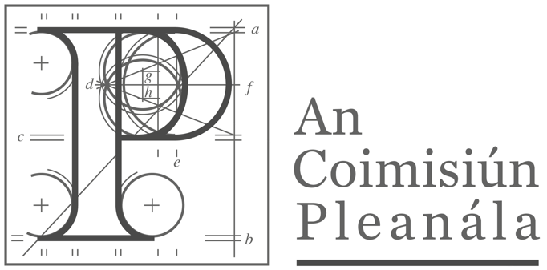 | Oral Hearing Agenda
 | ACP -322828-25

Case | Compulsory Purchase Order of land at Kilkee, Co.Clare  Uisce Eireann Compulsory Purchase (Wastewater Treatment Plant) Order 2025
Date | Tuesday 21st October 2025
Start Time | 10.00 AM
Venue | Virtually via Microsoft Teams

The purpose of the oral hearing is to provide an opportunity for all parties, who wish to do so, to make further submissions beyond their written objections, and to allow the inspector to seek clarification on any relevant issues arising and objections made. Parties will also have the opportunity to ask questions or seek clarification on submissions made at the hearing.
There is no obligation on any party to make a submission to the oral hearing or to ask questions of the other parties. All written submissions already received will be considered by the inspector and the Coimisiun. For this reason, submissions previously made in writing should not be reiterated at the oral hearing.
All parties are requested to be mindful of the nature of this application and to ensure that presentations or questions are relevant to the nature of this CPO. You are reminded that the Coimisuin has no role or jurisdiction in the determination, or the assessment, of compensation and that any submission made to this hearing should bear this in mind, as no discussion regarding compensation will be facilitated.

On completion of the oral hearing, the Inspector will prepare a report and recommendation on the case for the Coimisiun. The decision to confirm or annul the CPO will be made by the Coimisiun.

The Coimisiun may direct the payment of a contribution towards the costs to any person appearing at an oral hearing, which have been incurred by that person, as a consequence of appearing at the hearing. Any payment will be at the Coimisiun’s discretion. Any application for costs should be made in writing to the Coimisiun within three weeks of the date of this hearing.

If you intend to provide a written copy of your submission or use visual aids when speaking (presentations, maps, photos, etc.), these should be submitted in a digital format to the Coimisiun at least 2 working days in advance of participation in the hearing (and will be retained on the case file after the oral hearing).

Submissions presented to this oral hearing will be recorded by a service provider organised by An Coimisiun Pleanála. You are not permitted to record the proceedings of the oral hearing.

The agenda and order of appearance for the oral hearing is set out below, along with a timetable. Parties should please note that this timetable is indicative only and may vary during the course of the oral hearing.

AGENDA
21st October 2025
 | 10.00 AM: Opening of Hearing by Inspector
1. | 10.15 AM: Submission by Uisce Eireann  i. Brief overview of CPO.  ii. Justification for land acquisition with reference to alternatives considered.  iii. Uisce Eireann response to written submissions made by the Objectors.
2. | 10.45 AM: Break (15 mins)
3. | 11.00AM: Submission by Objectors, elaborating on written submissions  - Antoinette Coffey  - Paul Mullins Chairman of Brideford Properties Ltd.
4. | 12.00AM: Questions between parties as follows:  i. Objectors to Uisce Eireann  ii. Uisce Eireann to Objectors  iii. Inspector to Uisce Eireann
5. | 13.00-14.00 PM: Break
6. | 14.00 PM: Closing Comments (if required)  i. Antoinette Coffey  ii. Paul Mullins Charman of Brideford Properties Ltd  iii. Uisce Eireann  (No new issues or material permitted)
7. | 15.00PM: Closing of Oral Hearing

Appendix: Order of Appearance for Objectors

Objectors
- Antoinette Coffey
- Paul Mullins Chairman of Brideford Properties Ltd
Observers
None

